**Ethereum Prediction analysis: Using LSTM, RNN, & GRU**

**Introduction**

Time series prediction plays an important role in various fields such as finance, Weather forecasting, and resource management. In this project, the three advanced models: (i) Long Short-Term Memory (LSTM), (ii) Recurrent Neural Network (RNN), and (iii) Gated Recurrent Unit (GRU) are utilized for predicting the future trends. This project focused on predicting the future prices of Ethereum cryptocurrency based on its past performance. The main aim is to leverage these powerful models to make accurate predictions and gain insights into the behaviour of the Ethereum prices over the time.

**Methodology**

1. **Data Collection and Preprocessing**
   1. Historical Ethereum price data from a CSV file containing hourly data is collected from the Kaggle.
   2. Data preprocessing steps included sorting by date, handling missing values, dropping unnecessary columns, and creating datetime features.
2. **Model Building and Training**
   1. Three recurrent neural network architectures are used: LSTM, RNN, and GRU.

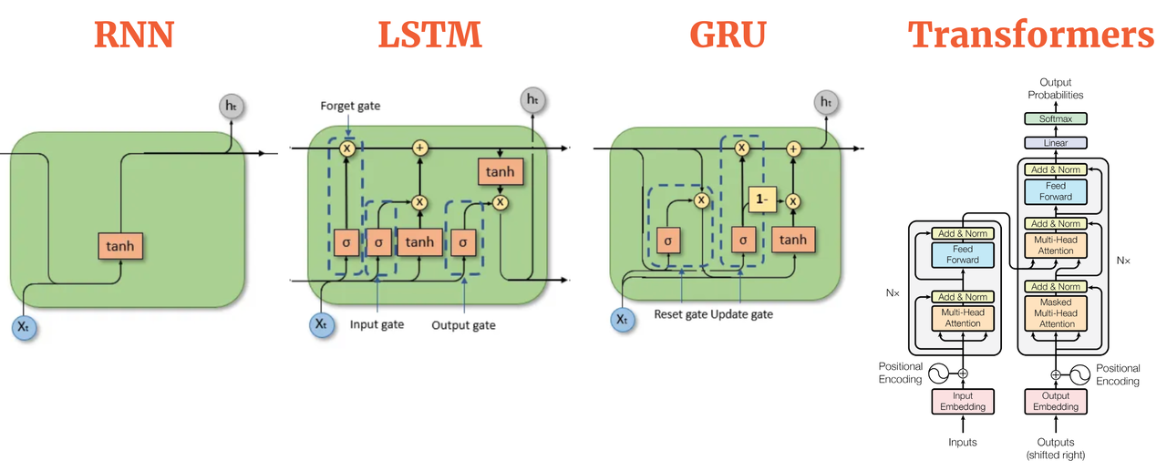

* 1. Sliding window approach was used to generate input sequences and target values for training.
  2. The dataset was split into training and testing sets (80% training, 20% testing).
  3. Each model was trained for 5 epochs with a batch size of 100 using Mean Squared Error (MSE) loss.

1. **Evaluation**
   1. Each model's performance is evaluated using the coefficient of determination (R-squared) metric.
   2. Predictions were made on the test set, and the R-squared score was calculated for each model.

**Results**

1. **Model Performance**
   * LSTM Model: R-squared = 0.985
   * RNN Model: R-squared = 0.972
   * GRU Model: R-squared = 0.995
2. **Visualization**
   * Actual vs. predicted values were plotted for each model in one plot as shown in the below figure.

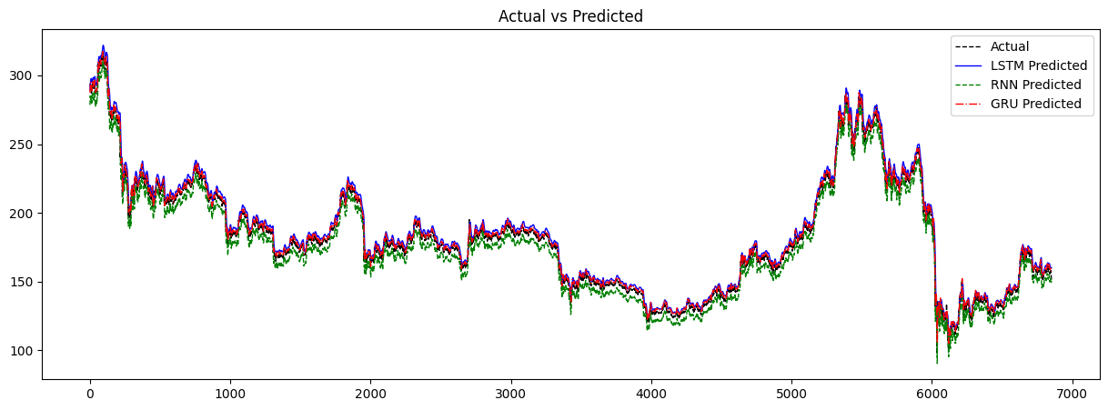

* + GRU predictions closely followed the actual values, indicating the highest accuracy among the three models.
  + RNN and LSTM models also demonstrated good predictive performance but showed slightly lower accuracy compared to GRU.
  + The following figure represents the plot of combined historical and predicted values. Red line represents the Predicted data while black represents the Historical price values of Ethereum.

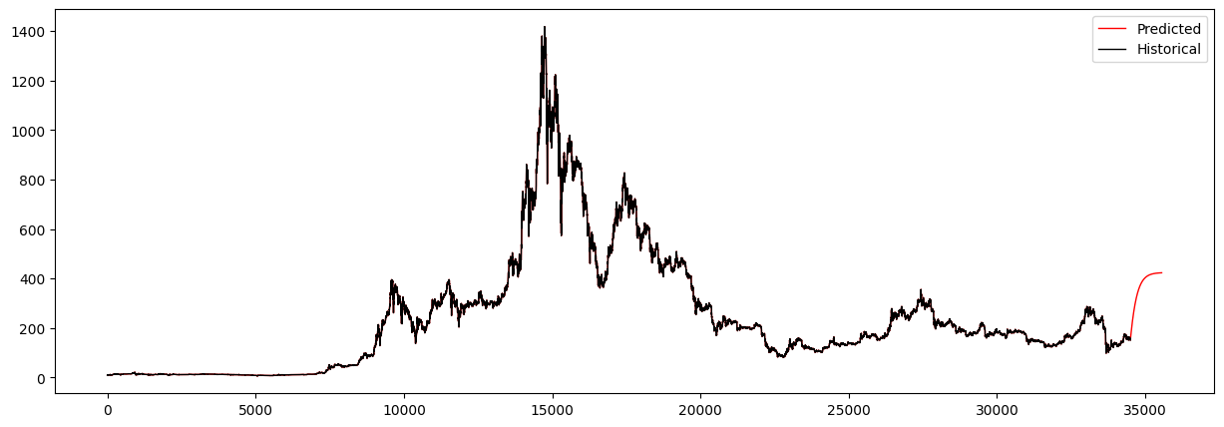

**Discussion**

* GRU outperformed RNN and LSTM in terms of predictive accuracy and time complexity, which can be attributed to its ability to capture long-term dependencies in time series data. RNN took so much time when compared to other two models to train on the data.
* RNN and LSTM models also yielded satisfactory results, indicating their effectiveness in time series prediction tasks.
* The sliding window approach proved effective in generating input-output pairs for training recurrent neural networks on time series data.
* Further experimentation with hyperparameters and model architectures could potentially improve the predictive performance of all models.

**Conclusion**

In this project, the application of LSTM, RNN, and GRU models for time series prediction of Ethereum cryptocurrency prices was explored. GRU demonstrated the highest predictive accuracy among the three models, followed by LSTM and RNN. The study highlights the effectiveness of recurrent neural networks in capturing temporal dependencies and their potential for real-world applications in financial forecasting and other time series prediction tasks.

|  |  |
| --- | --- |
| **Name:** | Venkata Sree Nandini Chavva |
| **Roll no.:** | 21BDS0281 |
| **Course:** | Data Science (CSE) |